H S II Year Commerce - 2020
SUBJECT: C M S
R G Baruah College
by Dr. A K. Borah _________________________________

Set definitions : A set is a collection of some objects (elements).
For example, cat, elephant, tiger, and rabbit are animals. When, these animals are considered collectively, it's called set.
Set Membership, Equality, and Subsets - An element of a set is an object directly contained within that set. For example, 1 ∈ {1, 2, 3} and Ø ∈ {Ø}, but 1 ∉ Ø and 1 ∉ {2, 3}. Note that 1 ∉ {{1}}, and {1} ∉ {1}, but {1} ∈ {{1}}.

Equality of sets : Two sets are equal if they contain the same elements. For example, we have that {1, 2} = {2, 1} and that {Ø} = {Ø}.
However, {Ø} ≠ {{Ø}}, because each set contains an element the other does not.
A set and a non-set are never equal; in particular, this means x ≠ {x} for any x. A set A is a subset of a set B (denoted A ⊆ B) if every element of A is also an element of B: ℕ ⊆ ℤ {1, 2, 3} ⊆ {1, 2, 3, 4} {1} ⊆ {1, {1}, {{1}}}

Set Operations: The set { x | some property of x } is the set of all objects x that satisfy the given property. Formally, we have that w ∈ { x | some property of x } if and only if the specified property holds for w.
[1] The set A ∪ B is the set { x | x ∈ A or x ∈ B }. Equivalently, x ∈ A ∪ B if and only if x ∈ A or x ∈ B.
[2] The set A ∩ B is the set { x | x ∈ A and x ∈ B }. Equivalently, x ∈ A ∩ B precisely if x ∈ A and x ∈ B.
[3] The set A – B is the set { x | x ∈ A and x ∉ B }. This set is also sometimes denoted A \ B.
[4] The set A Δ B is the set { x | exactly one of x ∈ A and x ∈ B is true }.

Power Sets : The power set of a set S, denoted ℘(S), is the set of all subsets of S. Using set-builder notation, this is the set ℘(S) = { U | U ⊆ S }.

Cantor's Theorem states that |S| < |℘(S)| for every set S.
Special Sets : The set Ø = { } is the empty set containing no elements.
The set ℕ = {0, 1, 2, 3, 4, … } is the set of all natural numbers.
We treat 0 as a natural number.
The set ℤ = {…, -2, -1, 0, 1, 2, …} is the set of all integers.
The set ℝ consists of all the real numbers.
The set ℚ consists of all rational numbers.
Cardinality : The cardinality of a finite set S (denoted |S|) is the natural number equal to the number of elements in that set. The cardinality of ℕ (denoted |ℕ|) is ℵ₀ (pronounced “aleph-nought”). Two sets have the same cardinality if there is a way of pairing up each element of the two sets such that every element of each set is paired with exactly one element of the other set.

For example, if A = {1, 2, 3} and B = {1, 2, 3, 4, 5} then A Í B (Í means is a subset of). If A = {1, 2, 4, 8}, then n(A) = 4. This is because n(A) means the number of members in set A. The universal set is the set of all sets.

The set that contains all the elements of a given collection is called the universal set and is represented by the symbol ‘µ’, pronounced as ‘mu’.
For two sets A and B,
- n(AᴜB) is the number of elements present in either of the sets A or B.
- n(A∩B) is the number of elements present in both the sets A and B.
- n(AᴜB) = n(A) + (n(B) – n(A∩B)

For three sets A, B and C,
- n(AᴜBᴜC) = n(A) + n(B) + n(C) – n(A∩B) – n(B∩C) – n(C∩A) + n(A∩B∩C)

Exercises No 1:

In a class Higher secondary of Science of 100 students, 35 like science and 45 like math. 10 like both. How many like either of them and how many like neither?

Solution:

Total number of students, n(µ) = 100
Number of science students, n(S) = 35
Number of math students, n(M) = 45
Number of students who like both, n(M∩S) = 10
Number of students who like either of them,
n(MᴜS) = n(M) + n(S) – n(M∩S)
→ 45+35-10 = 70
Number of students who like neither = n(µ) – n(MᴜS) = 100 – 70 = 30

To solve the problems on sets is by drawing Venn diagrams, as shown below.

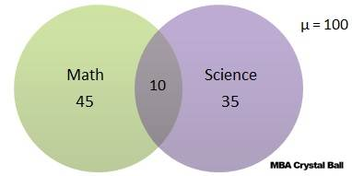
As we know that one picture is worth a thousand words. One Venn diagram can help solve the problem faster and save time. This is especially true when more than two categories are involved in the problem.
Let us see some more solved examples.
++++++++++++++++++++++++++++++++++++++++

Exercise No 2:

There are 30 students in a class. Among them, 8 students are learning both English and French. A total of 18 students are learning English. If every student is learning at least one language, how many students are learning French in total?

Solution:
The Venn diagram for this problem looks like this.

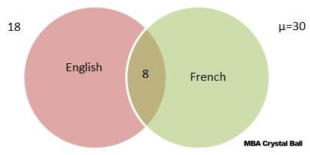

Every student is learning at least one language. Hence there is no one who fall in the category ‘neither’.
So in this case, n(EᴜF) = n(µ).
It is mentioned in the problem that a total of 18 are learning English. This DOES NOT mean that 18 are learning ONLY English. Only when the word ‘only’ is mentioned in the problem should we consider it so.
Now, 18 are learning English and 8 are learning both. This means that 18 – 8 = 10 are learning ONLY English.
n(µ) = 30, n(E) = 10
n(EᴜF) = n(E) + n(F) – n(E∩F)
30 = 18+ n(F) – 8
n(F) = 20
Therefore, total number of students learning French = 20.
Note: In this question it was only about the total number of students learning French and not about those learning ONLY French, which would have been a different answer, 12.
Finally, the Venn diagram looks like this.
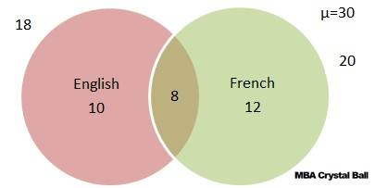

++++++++++++++++++++++++++++

Exercise No 3:
Among a group of students, 50 played cricket, 50 played hockey and 40 played volley ball. 15 played both cricket and hockey, 20 played both hockey and volley ball, 15 played cricket and volley ball and 10 played all three. If every student played at least one game, find the number of students and how many played only cricket, only hockey and only volley ball?

Solution:
n(C) = 50, n(H) = 50, n(V) = 40
n(C∩H) = 15
n(H∩V) = 20
n(C∩V) = 15
n(C∩H∩V) = 10
No. of students who played at least one game
n(CᴜHᴜV) = n(C) + n(H) + n(V) – n(C∩H) – n(H∩V) – n(C∩V) + n(C∩H∩V)
= 50 + 50 + 40 – 15 – 20 – 15 + 10
Total number of students = 100.
Let a denote the number of player who played cricket and volleyball only.
Let b denote the number of player who played cricket and hockey only.
Let c denote the number of player who played hockey and volleyball only.
Let d denote the number of player who played all three games.
Accordingly, d = n (CnHnV) = 10
Now, n(CnV) = a + d = 15
n(CnH) = b + d = 15
n(HnV) = c + d = 20
Therefore, a = 15 – 10 = 5 [cricket and volleyball only]
b = 15 – 10 = 5 [cricket and hockey only]
c = 20 – 10 = 10 [hockey and volleyball only]
No. of students who played only cricket = n(C) – [a + b + d] = 50 – (5 + 5 + 10) = 30
No. of students who played only hockey = n(H) – [b + c + d] = 50 – ( 5 + 10 + 10) = 25
No. of students who played only volley ball = n(V) – [a + c + d] = 40 – (10 + 5 + 10) = 15
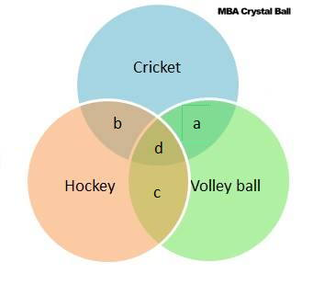
Alternatively, we can solve also it faster with the help of a Venn diagram.
The Venn diagram for the given information is as follows.
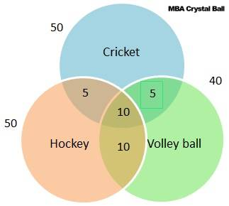
Subtracting the values in the intersections from the individual values gives us the number of students who played only one game.
+++++++++++++++++++++++++++++++++++++++++++

We can also define a set by mathematically stating the properties satisfied by the elements in the set. In particular, we may write
A={x|x satisfies some property}A={x|x satisfies some property}
or
A={x:x satisfies some property}A={x:x satisfies some property}
The symbols "|""|" and ":"":" are pronounced "such that."

Example
The following sets are used:
- The set of natural numbers, N={1,2,3,⋯}N={1,2,3,⋯}.
- The set of integers, Z={⋯,−3,−2,−1,0,1,2,3,⋯}Z={⋯,−3,−2,−1,0,1,2,3,⋯}.
- The set of rational numbers QQ.
- The set of real numbers RR.
- Closed intervals on the real line. For example, [2,3][2,3] is the set of all real numbers xx such that 2≤x≤3 2≤x≤3.
- Open intervals on the real line. For example (−1,3)(−1,3) is the set of all real numbers xx such that −1<x<3 −1<x<3.
- Similarly, [1,2)[1,2) is the set of all real numbers xx such that 1≤x<2 1≤x<2.
- The set of complex numbers CC is the set of numbers in the form of a+bia+bi, where a,b ∈Ra, b∈R, and i=−1−−−√i=−1.

Example
Here are some examples of sets defined by stating the properties satisfied by the elements:
- If the set CC is defined as C={x|x∈Z,−2≤x<10}C={x|x∈Z,−2≤x<10}, then C={−2,−1,0,⋯,9}C={−2,−1,0,⋯,9}.
- If the set DD is defined as D={x2|x∈N}D={x2|x∈N}, then D={1,4,9,16,⋯}D={1,4,9,16,⋯}.
- The set of rational numbers can be defined as Q={ab|a,b∈Z,b≠0}Q={ab|a,b∈Z,b≠0}.
- For real numbers aa and bb, where a<ba<b, we can write (a,b]={x∈R∣a<x≤b}(a,b]={x∈R∣a<x≤b}.
- C={a+bi∣ a,b∈R, i=−1−−−√}C={a+bi∣a,b∈R,i=−1}

Two sets are equal if they have the exact same elements. Thus, A=BA=B if and only if A⊂BA⊂B and B⊂AB⊂A. For example, {1,2,3}={3,2,1}{1,2,3}={3,2,1}, and {a,a,b}={a,b}{a,a,b}={a,b}. The set with no elements, i.e., ∅={}∅={} is the null set or the empty set. For any set AA, ∅⊂A∅⊂A.

The universal set is the set of all things that we could possibly consider in the context we are studying. Thus every set AA is a subset of the universal set. In this book, we often denote the universal set by SS (As we will see, in the language of probability theory, the universal set is called the sample space.) For example, if we are discussing rolling of a die, our universal set may be defined as S={1,2,3,4,5,6}S={1,2,3,4,5,6}, or if we are discussing tossing of a coin once, our universal set might be S={H,T}S={H,T} (HH for heads and TT for tails).

*******************

